**DOKUZ EYLUL UNIVERSITY**

**ENGINEERING FACULTY**

**DEPARTMENT OF COMPUTER ENGINEERING**

**CME1251 PROJECT BASED LEARNING – 1**

**FINAL REPORT**

**PROJECT – 2**

**LIFE ON MARS**

**by**

**Selda Turgut**

**Sarp Deniz Topaloğlu**

**Ejder Davarcı**

**Kerem Kalıntaş**

**Lecturers**

**Doç.Dr. Semih Utku**

**Dr. Özge Kart**

**IZMIR**

**02.12.2022**

CHAPTER ONE

PROGRESS DESCRIPTION

We shared operations. In the first week we did only operations 2 and 16. In the second and third week each of us wrote our operations and finish the game. In the last week we added colored printing. Tested and debugged our code. Commented functions and made it much readable.

CHAPTER TWO

TASK SUMMARY

* 1. Completed Tasks

SELDA TURGUT

This project consisted of operations. First of all, I shared the operations with my friends. I did the operations in the range of eight and twelve. Last week, I prepared the presentation and the poster with my friends.

SARP TOPALOĞLU

We shared operations. As my part, I did operation five to eight. Also worked on operations eight and sixteen. Helped preparing poster and presentation.

KEREM KALINTAŞ

I wrote operations 11 from 17. Helped my teammates in their part of the code. Tested the code and solved errors. Added comments in the code to make it more understandable.

EJDER DAVARCI

We deployed the initial task distribution deployment operations.I was given one to four.And I did it. I also took part in the production of posters.

* 1. Incomplete Tasks: Reasons and Explanations

We completed all of the operations. There is no incompleted tasks.

* 1. Additional Improvements ~~to the Project~~

SELDA TURGUT

We applied the coloring process to the code. We've added comment lines to better explain the code. We've improved the variable names.

SARP TOPALOĞLU

We added operation descriptions.

KEREM KALINTAŞ

We added colored printing to make it more readable. We included codon count and gender of the DNA when printing strands.

EJDER DAVARCI

We colored the output and added comments.

CHAPTER THREE

EXPLANATION of algorıthms

* 1. Screenshots

At the start of the game we print the information of operations. User selects a operation between 1 and 17. Selected operation runs and prints results.

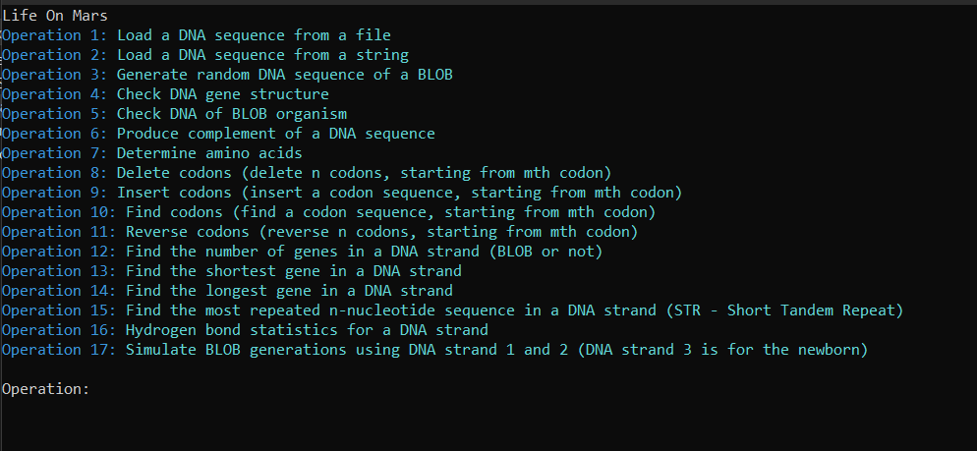

* 1. Functions

Functions that we wrote to run our code:

* GetOperationInput(string operation_name)
* GetInput(string var_name)
* PrintStrand(string name, char[] strand)
* RemoveCharacter(string input, char c)
* RemoveWhiteSpace(string input)
* CheckStrand(char[] strand)
* IsStartCodon(char[] c)
* IsStopCodon(char[] codon)
* GetDnaType(string input, int index)
* CopyToStrand(char[] strand, string str, int start)
* SetDNA(char[] strand, int dna_type)
* GetCodon(char[] strand, int index)
* SetCodon(char[] strand, int index, char[] codon)
* GetNextGene(char[] strand, ref int index)
* GenerateRandomDNA(char gender, int dna_type)
* GetGenderOfStrand(char[] strand)
* Procreate()
* GetFaultyCodonCount()
* CheckDNAStructure()
  1. Algorithms and Solution Strategies

SELDA TURGUT

We used arrays and string variables in the code. We also made use of some functions(GetInput,PrintStrand). We've added a lot of comment lines to explain the code.

We tried operations and tried to fix the problems.

SARP TOPALOĞLU

In operation 6, I identified nucleotide types to be compenent nucleotides to be compenent DNA strand. In operation 7, used switch case to match codons with amino acids. I tried to shorten operation 7 but I couldn't. In operation 8, I used nested loops.

KEREM KALINTAŞ

We wrote a lot of functions to simplify the operations. One of them is a function called “GetNextGene”. This function returns next gene in a char array starting with a start codon and ending with a stop codon. We used this function in operations 5, 12, 13, 14 and 17.

EJDER DAVARCI

I took the text file of operation 1 and processed it. In operation 2,I took it as a string and processed it.We randomly assigned blob DNA in operation 3. We checked whether the DNA obtained in operation 4 was suitable for blob DNA.

CHAPTER FOUR

PROBLEMS ENCOUNTERED

SELDA TURGUT

When I started the project, I couldn't decide which structures to use, so I constantly asked questions to my teachers. It took me some time to learn about Arrays but eventually I learned it and used it in my code. I had to use some function assignments. I researched constantly for this, but finally I managed to run my code without errors.

SARP TOPALOĞLU

I had thought that using string arrays was forbidden. It was very hard to write operation 7 with char array so we asked our teacher if we can use. Then we learned that it isn't forbidden so we made some changes on our code.

KEREM KALINTAŞ

There was lots of operations to execute. My problem was reducing the code repetition. To solve that we wrote lots of utility functions and reduced code repetition in similar operations.

EJDER DAVARCI

I was encountering wrong results in the 4th operation. I got help from the group to solve this situation.I had trouble checking whether the codons were triples or not, and we solved it by converting it to a char array and checked if it was divided into 3.

CHAPTER FIVE

conclusıon

As a result, we examined the gene functioning of a life form discovered on Mars. We identified the problems with DNA. We worked on DNA. We tried to write code using the information we saw in the algorithm lesson. We used the code C# programming language. We shared work with our teammates. Everyone did their own operations. We constantly communicated with our teammates. We helped each other. We gained the ability to carry out a project with our teammates. We are very happy to be involved in such a project . Thank you to all our teachers.

REFERENCES

<https://learn.microsoft.com/enus/dotnet/api/system.console.foregroundcolor?view=net-6.0>

<https://learn.microsoft.com/en-us/dotnet/api/system.random?view=net-7.0>

<https://learn.microsoft.com/en-us/dotnet/api/system.io.file.readalltext?view=net-7.0>

<https://www.w3schools.com/>

**AppendIx A**

Poster/Web page of the Project

**AppendIx B**

Code of the Project